

Faculty of Engineering and Technology Electrical and Computer Engineering Department **Computer Networks Laboratory (ENCS4130) Experiment No. 9 Report**

**Internet Protocol Version 6 (IPv6) Configuration**

### **Student’s Name**: Mohammad Salem **Student’s Number**: 1200651

### **Instructor: Dr**. Abdalkarim Awad **Section**: 6

### **Teaching Assistant**: Eng. Katy Sadi

### **Date**: 24/5/2024

# Abstract

The main aim of this experiment is centralized about discovering, configuring and verifying IPv6 routing with Cisco routers. Moreover, configuring the static Ipv6 routing and the dynamic routing protocol RIPng.

**Table of Contents**

1. Abstract I

2. Theory 1

2.1 IPv6 1

2.2 Address Types 3

2.3 Reserved IPv6 Addresses 4

2.4 Configuring Cisco Routers with IPv6 4

2.5 IPv6 Routing Protocols 5

2.6 Static Routing 5

2.7 RIPng 5

2.8 Cisco Discovery Protocol 6

3. Procedure 7

3.1 Building the Topology 7

3.2 Configuring IPv6 for the PCs 9

3.3 Configuring IPv6 for the routers 9

3.4 Configuring Static Routing 10

3.5 Configuring RIPng Routing Protocol 10

3.6 Verifying the Configurations 11

4. Conclusion 12

5. Feedback ……………………………………………………………………………………………….13

6. References 14

**List of Figures**

**Figure 1: The Whole Topology** 7

**Figure 2: Networks IPs** 8

**Figure 3: Static Routing Testing** 11

**Figure 4: RIPng Routing Protocol Testing** 11

1. **Theory**

## 2.1 IPv6

IPv6 utilizes 128-bit addresses, providing a staggering count of 3.40292367 × 1038 addresses. Unlike IPv4, IPv6 addresses do not employ decimals. Instead, they consist of groups of four-digit hexadecimal numbers separated by colons. Fortunately, within each set of colons, leading zeros can be omitted. For instance, the address:

AA76:0000:0000:0000:0012:A322:FE33:2267

can be represented as:

AA76:0:0:0:12:A322:FE33:2267

Furthermore, a consecutive series of zeros can be replaced by a double colon once in each address. Hence, the same address:

AA76:0000:0000:0000:0012:A322:FE33:2267

can also be written as:

AA76::12:A322:FE33:2267

It's important to note that double colons can only occur once within an IP address and cannot be repeated. For instance, the address:

AA76:0000:0000:0012:A322:0000:0000:2267

can be written as either:

AA76::12:A322:0:0:2267

or

AA76:0:0:12:A322::2267

However, it cannot be written as:

AA76::12:A322::2267

since it contains two instances of the double colon [1].

## 2.2 Address Types

##### Unicast

Unicast addresses direct packets to a single interface, ensuring delivery to a specific destination [1].

##### Global unicast addresses

Similar to public addresses in IPv4, global unicast addresses originate from the range 2000::/3 [1].

##### Link-local addresses

Link-local addresses, starting with FE80::/10, resemble private addresses in IPv4. They are intended for local use, enabling the quick establishment of temporary LANs for meetings or small LANs that require local file sharing and service access without routing [1].

##### Multicast

Similar to IPv4, multicast addresses deliver packets to all interfaces subscribed to the multicast group [1].

##### Anycast

Anycast addresses also identify multiple interfaces on various devices, much like multicast addresses. However, unlike multicast, an anycast packet is delivered to the closest device based on routing distance, reaching only one device [1].

## 2.3 Reserved IPv6 Addresses

There are indeed numerous reserved addresses, there are some examples:

* 0:0:0:0:0:0:0:1, equivalent to ::1, represents the loopback address, similar to 127.0.0.1 in IPv4.
* 0:0:0:0:0:0:192.X.100.1 represents an IPv4 address in a mixed IPv6/IPv4 network environment.
* 2000::/3 denotes the range of global unicast addresses.
* FE80::/10 designates the range of link-local unicast addresses.

## 2.4 Configuring Cisco Routers with IPv6

The following commands are used to configure an IPv6 [1]:

Router(config)#interface <TYPE> <SLOT>/<PORT>

Router(config-if)# ipv6 address <IPV6-PREFIX>/<PREFIX-LENGTH>

## 2.5 IPv6 Routing Protocols

The following command is used to configure an IPv6 routing on a router [1]: Router(config)#ipv6 unicast-routing

Enabling IPv6 traffic forwarding requires activating it since it is initially disabled by default.

## 2.6 Static Routing

The following command is used to configure a static route [1]:

Router(config)#ipv6 route <IPV6-PREFIX>/<PREFIX-LENGTH> <IPV6-NEXTHOP- ADDRESS>

## 2.7 RIPng

RIPng shares similar primary features with RIPv2, such as being a distance-vector protocol with a maximum hop count of 15. However, there are differences in RIPng that make it a new version. In RIPng, routers maintain the next-hop addresses of their neighbor routers for each destination network in their routing table. The difference is that RIPng uses link-local addresses instead of global addresses to track the next-hop address.

One significant change in RIPng is how you configure or enable network advertisement. Instead of using a network command in router configuration mode, you now configure it directly from interface configuration mode. If you enable RIPng on an interface without entering router configuration mode and starting a RIPng process, a new RIPng process will be initiated automatically. Here's an example of the commands [1]:

Router(config)#interface <TYPE> <SLOT>/<PORT> Router(config)#ipv6 rip <RIP-ID> enable

The RIP-ID serves as a tag or identifier for the running RIPng process. It can be named instead of numbered. By using these commands, you can start a RIPng process without needing to access router configuration mode [1].

## 2.8 Cisco Discovery Protocol

Cisco Discovery Protocol (CDP) is a device-discovery protocol utilized by Cisco network equipment. It enables devices to exchange identifying messages through multicast addresses. CDP packets contain valuable information, including details about directly connected Cisco equipment like the operating system version and IP address. This information is utilized in network management software [2].

# Procedure

## 3.1 Building the Topology

Figure 1 shows a topology that built by Cisco Packet Tracer tool. It contains three routers, three switches and several PCs on different networks.

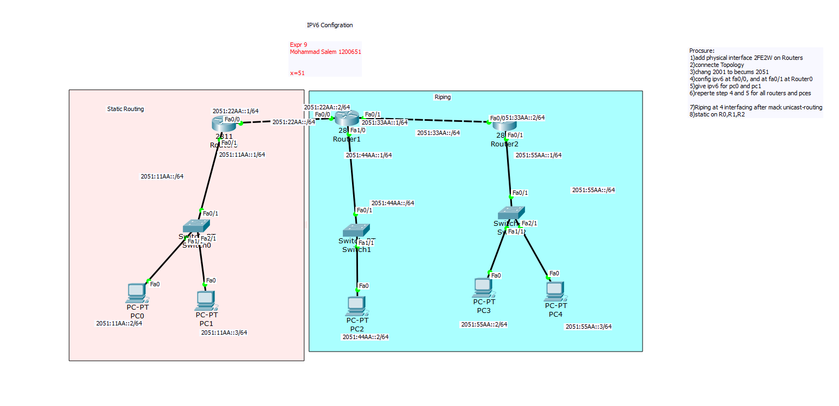

***Figure 1: The Whole Topology***

Figure 2 describes the IP for each network device, replace 2051: insisted of 2001: according of teaches assistance instructions in lab.

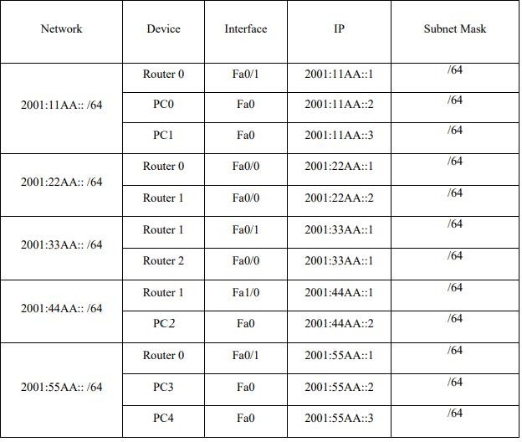

***Figure 2: Networks IPs***

## 3.2 Configuring IPv6 for the PCs

IPv6 addresses are configured on PCs by using the following steps:

* Click on PC0 and navigate to the desktop tab.
* Select the IP configuration option.
* Enter the IPv6 address (2001:11AA::2/64).
* Add the IPv6 gateway address (2001:11AA::1).

Repeat the above steps for PC1, PC2, PC3, and PC4, using the corresponding IPv6 addresses provided in Figure 2.

## 3.3 Configuring IPv6 for the routers

The following commands are used to configure IPv6 on an interface: Router(config)#interface <TYPE> <SLOT>/<PORT>

Router(config-if)# ipv6 address <IPV6-PREFIX>/<PREFIX-LENGTH> Router(config-if)# no shutdown

## 3.4 Configuring Static Routing

To enable IPv6 routing on a router:

Router(config)#ipv6 unicast-routing

The following command is used to add static route to a routing table:

#### Router(config)#ipv6 route <IPV6-PREFIX>/<PREFIX-LENGTH> <IPV6-NEXT-HOP- ADDRESS>

## 3.5 Configuring RIPng Routing Protocol

To enable IPv6 routing on a router: Router(config)#ipv6 unicast-routing

The following commands are used to configure RIPng on an interface: Router(config)#interface <TYPE> <SLOT>/<PORT> Router(config)#ipv6 rip <RIP-ID> enable

## 3.6 Verifying the Configurations

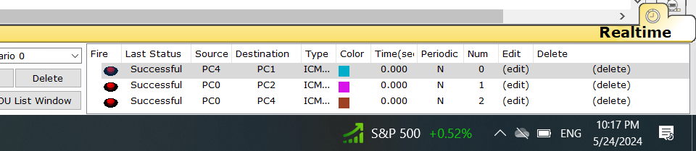

***Figure 3: Static Routing Testing***

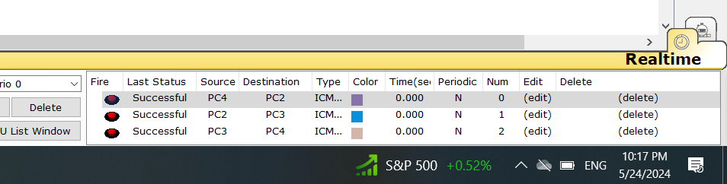

***Figure 4: RIPng Routing Protocol Testing***

1. **Conclusion**

To sum up, the aim of this experiment is achieved, the configuration, and verification of IPv6 routing using Cisco routers are discovered. Moreover, IPv6 routing protocols are discovered and configured.

# Feedback

The experiment was engaging and informative, offering a clear understanding of the concepts, also the time was suitable, so we finished it on time.

1. **References**
2. Electrical and Computer Engineers Department, Computer Networks lab Manual
3. <https://www.cisco.com/>